“Київський фаховий коледж зв’язку”

Циклова комісія комп’ютерної інженерії

**ЗВІТ ПО ВИКОНАННЮ**

**ЛАБОРАТОРНОЇ РОБОТИ №4**

з дисципліни “Операційні системи”:

**Тема: “Команди Linux для управління процесами”**

Виконали студенти

групи РПЗ-13А та РПЗ-13Б

Eleven Two Zeroes:

Vlad Sapozhnyk

Max Karpenko

Dmytro Onufriiev

Київ 2024

Робота студентів групи РПЗ-13А та РПЗ-13Б Eleven Two Zeroes: Vlad Sapozhnyk, Max Karpenko and Dmytro Onufriiev.

**Мета роботи:**

1. Отримання практичних навиків роботи з командною оболонкою Bash.
2. Знайомство з базовими командами для управління процесами.

**Матеріальне забезпечення занять:**

1. ЕОМ типу IBM PC.
2. ОС сімейства Windows та віртуальна машина Virtual Box (Oracle).
3. ОС GNU/Linux (будь-який дистрибутив).
4. Сайт мережевої академії Cisco netacad.com та його онлайн курси по Linux.

**Завдання для попередньої підготовки: *Created by Vlad Sapozhnyk***

**Хід роботи. *Created by Max Karpenko***

**1. Початкова робота в CLI-режимі в Linux ОС сімейства Linux:**

**1.3. Запустіть свою операційну систему сімейства Linux (якщо працюєте на власному ПК та її встановили) та запустіть термінал.**

**2. Дайте відповіді на наступні питання:**

* **Як вивести вміст директорії /proc? Де вона знаходиться та для чого призначена? Охарактеризуйте інформацію про її вміст?**

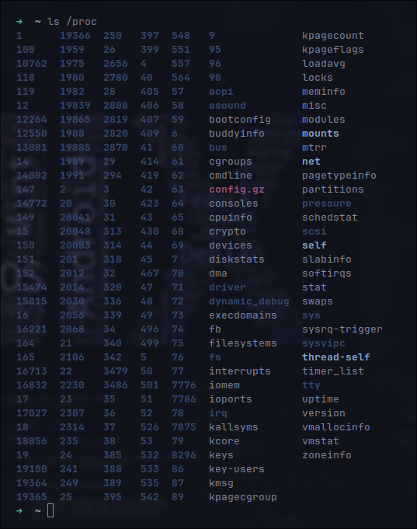

The /proc directory is located at the root of the Linux file system and is a virtual file system that does not take up disk space. It is designed to provide information about system resources and processes running in the operating system.

**The contents of /proc contain dynamic information about the system, such as:**

1. CPU details (/proc/cpuinfo),
2. Memory usage (/proc/meminfo),
3. Process information (directories named after their PIDs),
4. Kernel parameters, etc.

* **Як вивести інформацію про поточні сеанси користувачів. Якою командою це можна зробити?**



To display information about current user sessions in Linux, you can use the who command. This command displays a list of all users who are currently logged in to the system, along with information about the time they logged in, the terminal they connected from, and the IP address or hostname (in the case of remote access).

* **Які дії можна зробити в терміналі за допомогою комбінацій Ctrl + C, Ctrl + D та Ctrl + Z?**

1. **Ctrl + C:** Most often used to interrupt the execution of the current command or program in the terminal. This keyboard shortcut sends a SIGINT signal to the current process, which causes it to stop executing immediately. For example, if a command is taking too long and you want to stop it, you can use Ctrl + C.
2. **Ctrl + D:** Used to send an EOF (End of File) signal to the current terminal session. In the context of a shell, this means closing the input stream, which is often used to close a shell session or to end input in interactive programs that read input from the terminal. For example, if you enter the cat command without arguments, it will wait for input from the keyboard; entering Ctrl + D will tell cat that the input is complete.
3. **Ctrl + Z:** Used to temporarily pause the execution of the current command or program. This keyboard shortcut sends a SIGTSTP signal to the current process, which stops its execution and returns you to the shell. The process remains on the system as stopped, and you can continue its execution in the background or foreground with the bg (background) and fg (foreground) commands, respectively.

* **\*Чим відрізняється фоновий процес від звичайного. Де вони використовуються?**

**The normal process:** This is the process that runs in the foreground of the terminal. It receives input from the keyboard and sends the output to the terminal screen. The user can see its output on the screen and interact with it.

**Background process:** This is a process that runs in the background, that is, without being attached to the terminal. It does not display its output on the terminal screen, so the user does not see its output and cannot interact with it directly from the keyboard. Background processes are often used to perform tasks that take a lot of time or resources and do not require active user participation. For example, a script that processes large files can be run in the background so that the user can continue working on other tasks in the terminal.

Background processes are often started using special terminal characters, such as **&**, which allows you to run commands without locking the terminal, or using the key combination **Ctrl + Z** and the bg command, which puts a paused process into the background.

* **\*Опишіть наступні команди та поясніть що вони виконують – команда jobs, bg, fg.**

*The jobs, bg, and fg commands are built-in shell commands in Unix-like operating systems such as Linux. They are used to control tasks (processes) running in the terminal. Here are their main functions:*

**1. jobs**

The jobs command displays a list of all the tasks that have been running in the current shell session. It shows the status of each task (for example, whether it is running in the background, stopped, etc.) and gives each task a unique number. These numbers can be used with the bg and fg commands to identify specific tasks.

**2. bg**

The bg command is used to resume execution of a stopped process in the background. If you use bg without arguments, it will try to put the last stopped task in the background. You can also specify a specific job by using the job number, which can be found using the jobs command.

**3. fg**

The fg command is used to resume execution of a stopped process in the foreground. This means that the process will be attached to the terminal and the user will be able to interact with it again. As with the bg command, if you use fg without arguments, it will try to bring the last stopped task to the foreground. The command also allows you to specify a specific task by the number obtained from jobs.

* **\*\*Якою командою можна переглянути інформацію про запущені в системи фонові процеси та задачі?**

**ps:** The ps command is used to display information about active processes. You can use various options from ps to customize the output. For example, ps aux will show a complete list of processes running on the system, including background processes.

**jobs:** As already mentioned, the jobs command displays a list of tasks that have been started from the current terminal. It will show both stopped (suspended) and background tasks that are currently running.

**top or htop (extended version):** These programs provide a dynamic view of active processes on the system. They show detailed process statistics, including CPU and memory usage, and allow users to manage processes in real time. While top is a standard utility on most systems, htop may require a separate installation but provides a more user-friendly interface.

* **\*\*Як призупинити фоновий процес, як його потім відновити та при необхідності перезапустити?**

To pause a background process, you first need to find its number using the command that shows active processes, and then use the stop command, specifying this number. To resume a process, you can use the command to continue running the process in the background or move it back to the foreground. If you need to restart a process, you first stop it and then restart it again with the same parameters that were used when it was first started.

**3. Запустіть термінал, та в командному рядку виконайте наступні дії для ознайомлення з роботою з процесами:**

1. **запустіть команду top, проаналізуйте отриманий в цій команді результат та охарактеризуйте найбільш активні процеси у системі;**

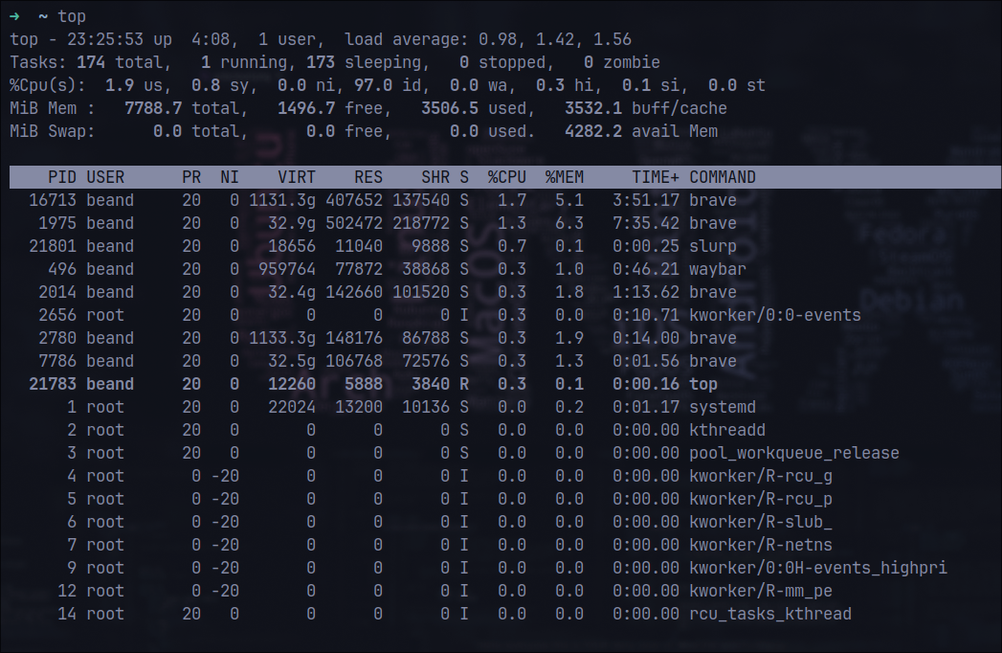

*Based on the output of the top command, we can make the following observations about the most active processes in the system:*

**Brave Browser:** Processes named brave occupy several positions in the list, showing high CPU and RAM usage. This indicates that the Brave browser is being actively used and may have many tabs open or be performing resource-intensive tasks. In particular, two Brave processes use 3.7% and 2.3% of CPU respectively, as well as significant amounts of RAM.

**Waybar:** The waybar process uses 0.7% CPU and 1.0% RAM, which is a relatively low load. Waybar is a status bar for Wayland and its activity is usually not very high.

**Telegram Desktop:** The telegram-desktop process is also among the active ones, using 0.3% of CPU and 9.2% of RAM. This indicates the active use of the messenger.

**System processes:** Processes such as kworker/u17:1-i915_flip and kworker/2:1H-events_highpri with a small CPU usage (0.3%) are part of the Linux kernel and perform background tasks related to hardware management and system events.

**The top command:** The top command itself, which is used for monitoring, also appears in the list, using 0.3% of the CPU. This is normal because top is actively updating system process data in real time.

1. **призупинити виконання команди top (треба використати комбінацію клавіш);**

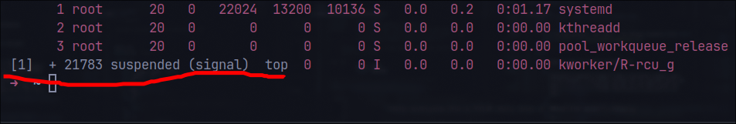

1. **вивести інформацію про процеси за допомогою команди ps;**

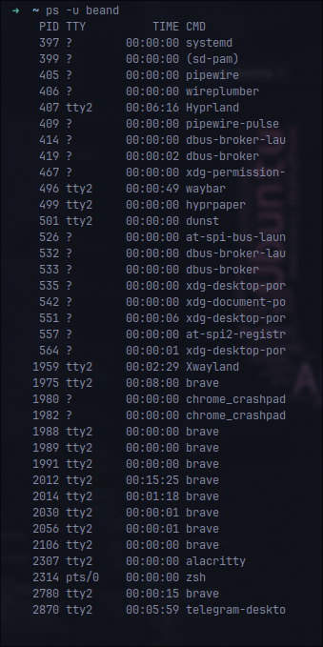

1. **\*наведіть 5 прикладів з використанням різних параметрів команди ps (наприклад, вивести тільки системні процеси, вивести процеси конкретного користувача, вивести процесів тощо). Опишіть, що саме роблять обрані Вами параметри**
   1. **Log all processes of the system:** ps -e
   2. **Display processes of a specific user:** ps -u <user>
   3. **Print the process tree:** ps -ejH
   4. **Display processes with a specific identifier (PID):** ps -p <PID>
   5. **Print system processes:** ps -e --deselect -N T
2. **\*\*передивіться чи є у Вас запущені фонові процеси, які саме?**

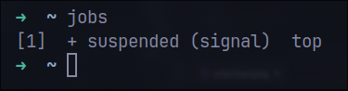

1. **\*\*відновити виконання призупиненого фонового процесу спочатку у позиції “на передньому плані” (foreground), потім ще раз його призупинити, а потім відновити його виконання у позиції “на задньому плані” (background)**

**Resume execution of a paused process in the foreground:** fg %1

**Pause the process in the foreground again:** ctrl + z

**Resume a paused process in the background:** bg %1

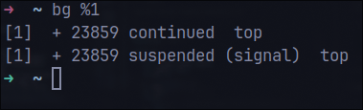

1. **завершити роботу даного фонового процесу.**

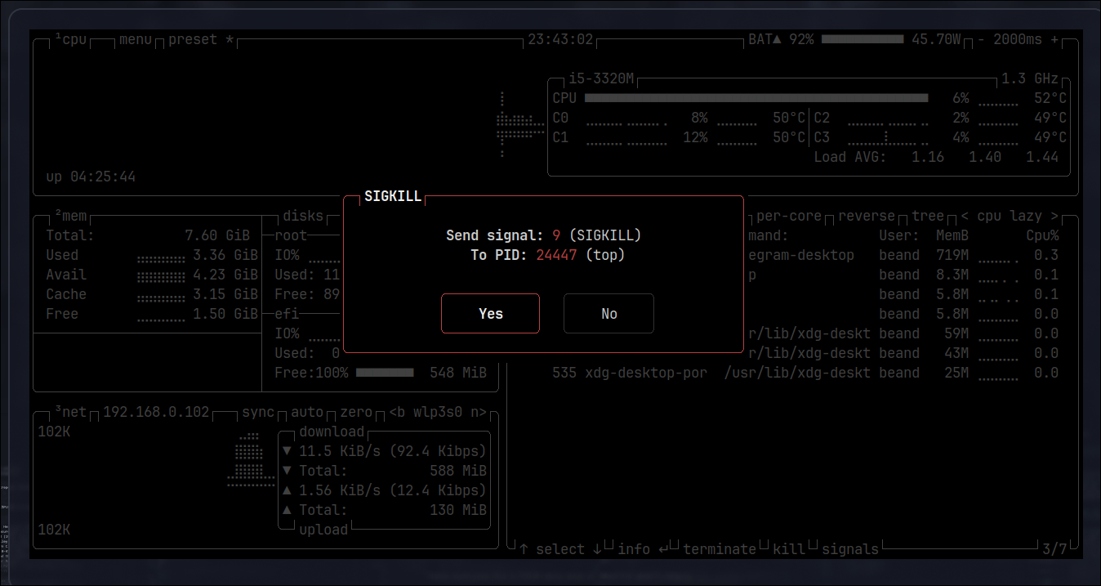

**Контрольнi запитання: *Created by Dmytro Onufriiev.***